# Module 4 – Pandas

**Panda / Jupyter**

**Method 1**

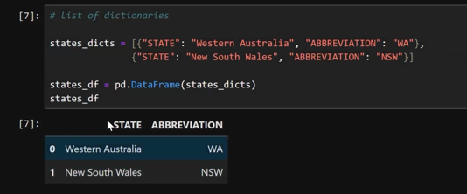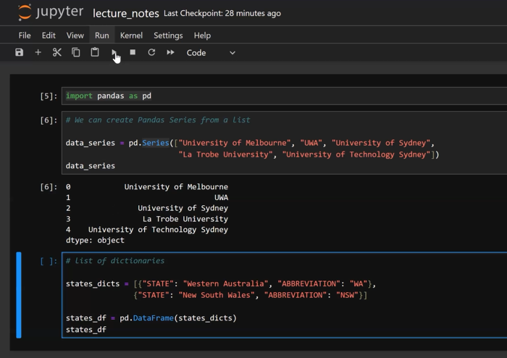

**Method 2 (mostly used)**

“State”: [“Western Australia”, “New South Wale”],

“Abbreviation: [“WA”, “NSW”]

**Day 1, Activity 4 – Data Frame**

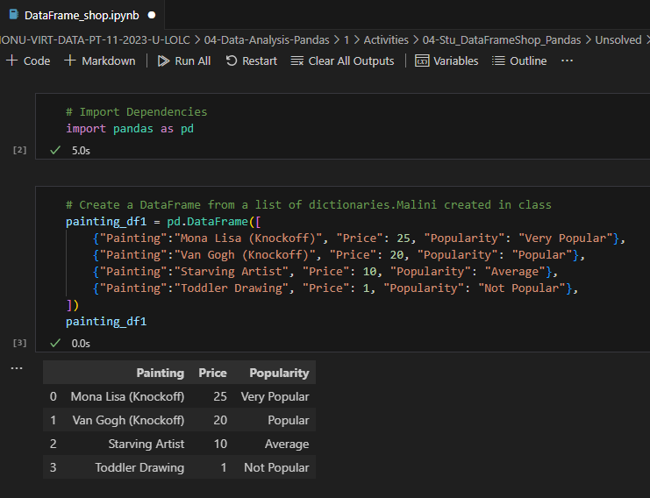**Method 1**

**Method 2 (to use used most of the time)**

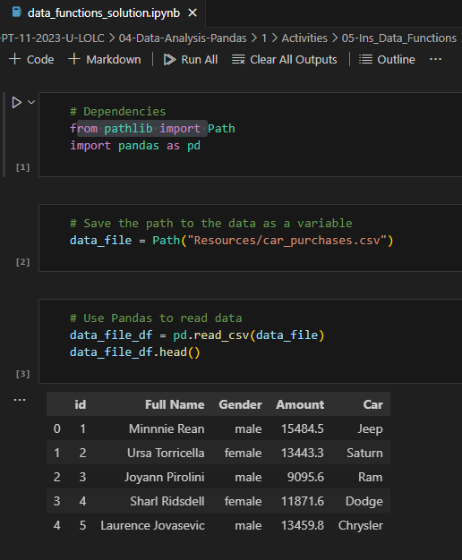**Day 1 , Activity 5 - Data_Functions**

**Describe (count, mean, std, min, max)**

**Mean / Sum / Unique / Value Count**

**Day 1, Activity 6 – Training Ground – Data Functions**

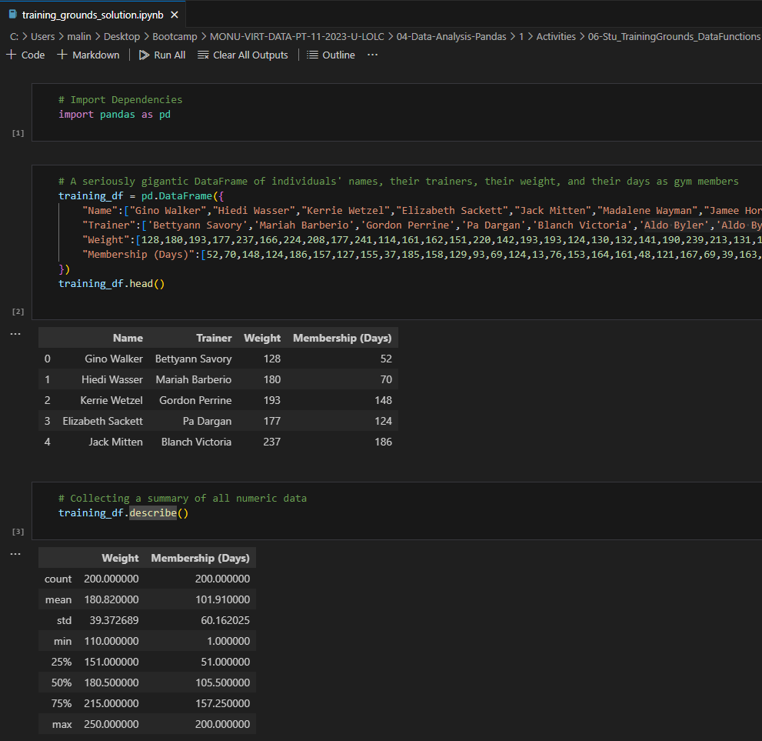

**Another way of putting the above is**

training_df[“Membership (Weeks)”] = training_df[“Membership (Days)”]/7

training_df

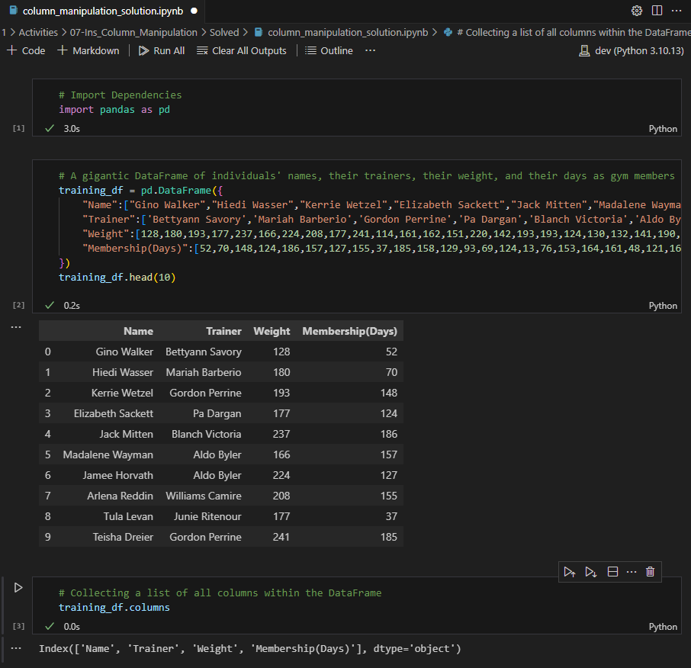**Day 1, Activity 7 – Column Manipulation**

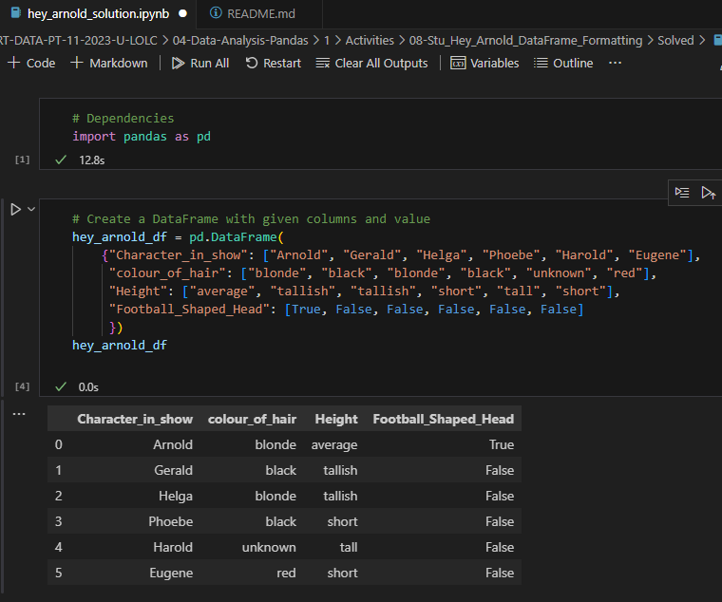**Day 1, Activity 8 – Data Frame Formatting**

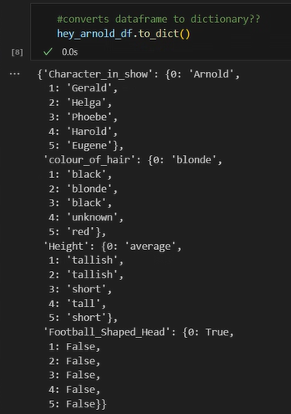

**Day 1, Activity 9 – Creating and Exporting to csv file**

**Day 1, Activity 10 – Creating and Exporting to csv file (Student activity)**

**Day 1, Activity 11 – Display of Summary Data (Unique + len = count) , Min and Max**

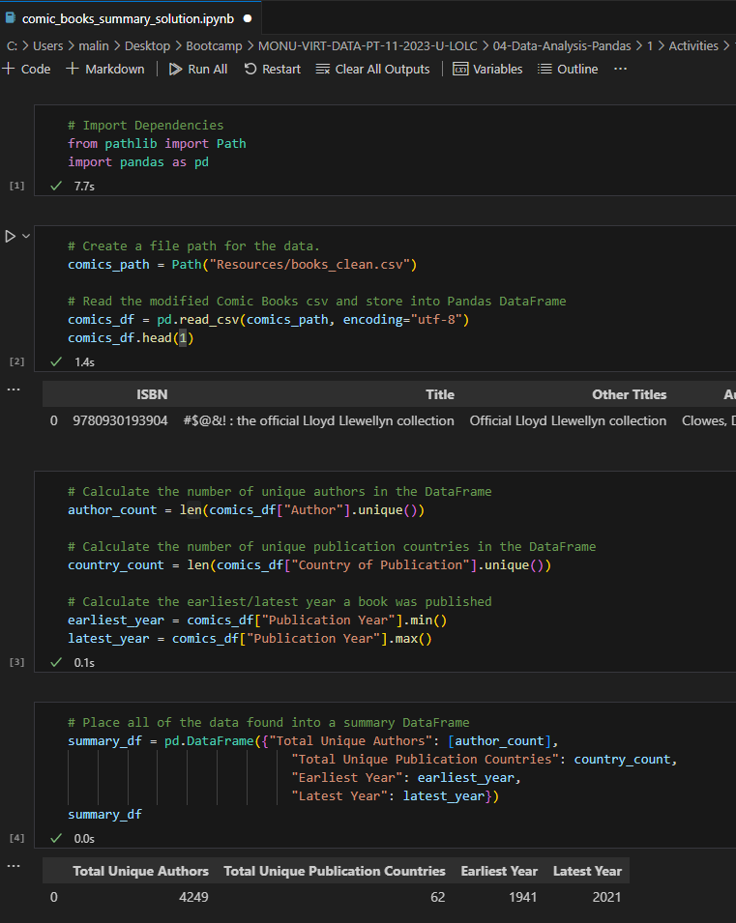

**Day 2, Activity 1 – Loc and iLoc**

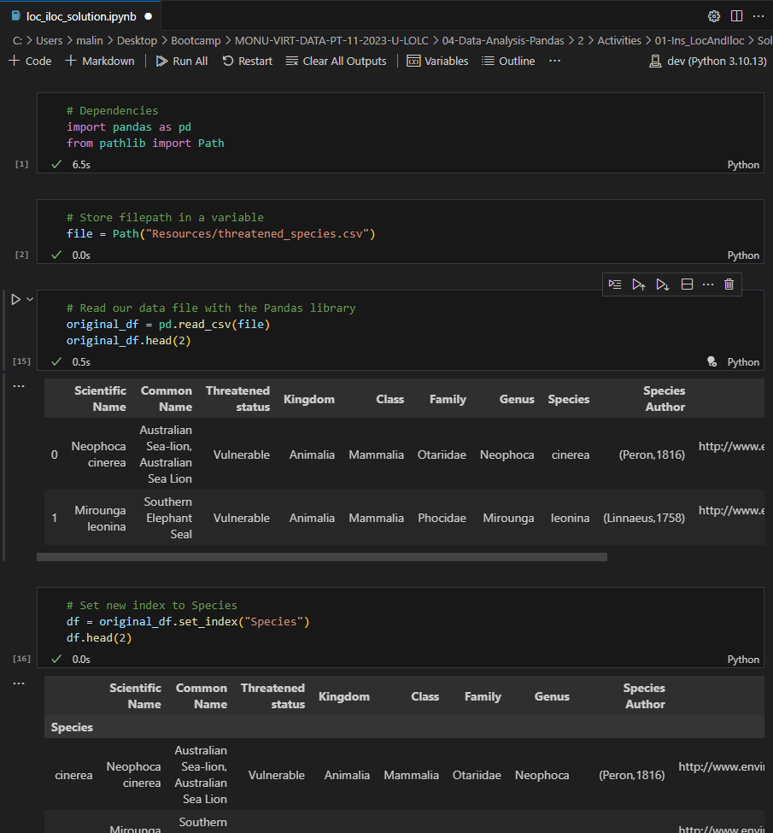

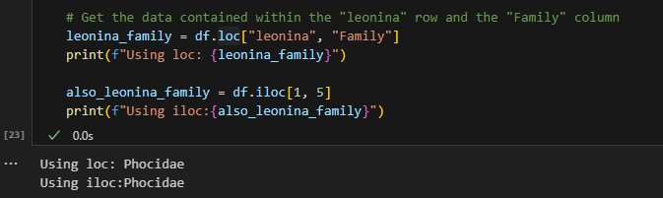

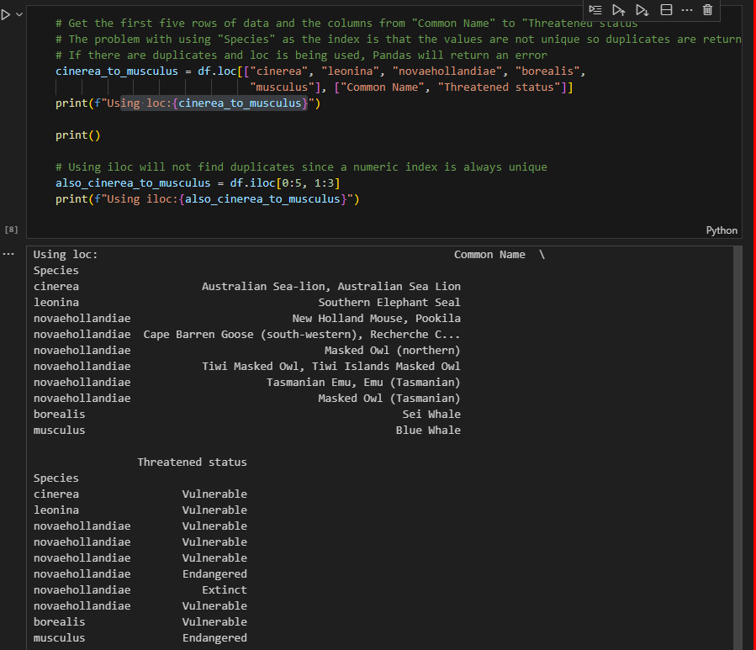

**Day 2, Activity 2**

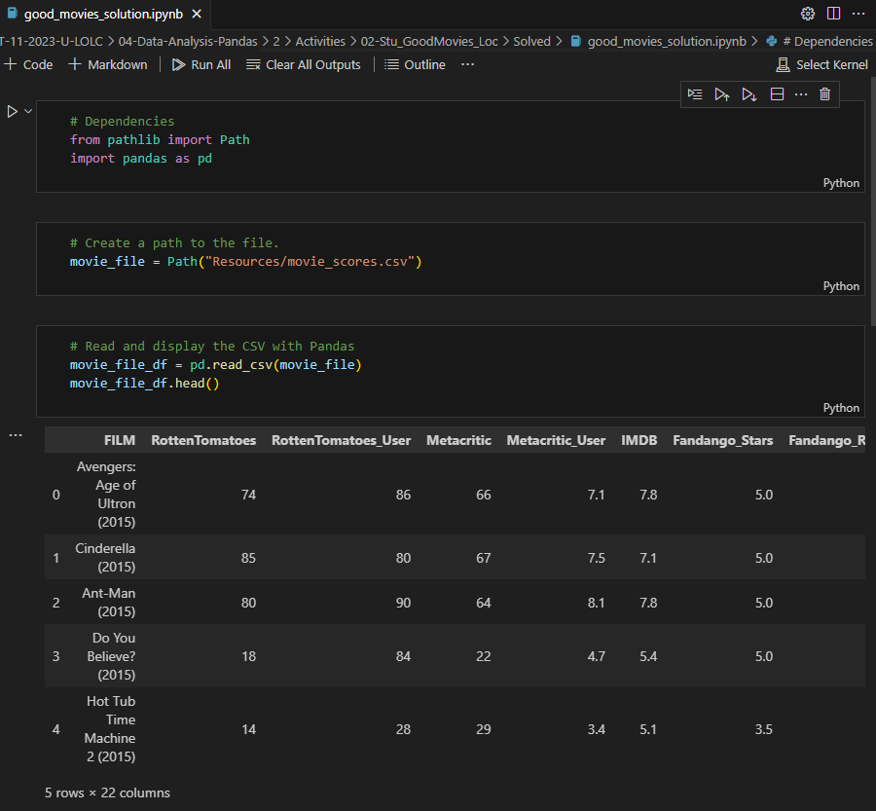

**Day 2, Activity 3 – Cleaning Data**

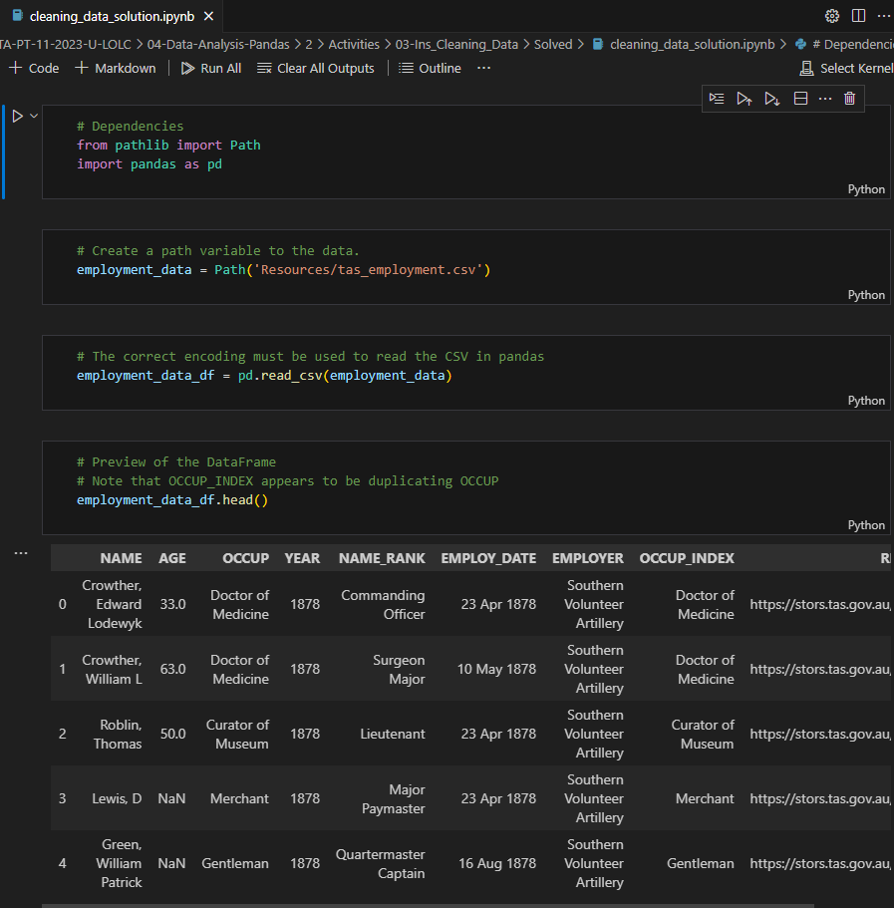

**Day 2, Activity 4 – Cleaning Data**

**# Save the clean DataFrame to a CSV file without the index**

**portugal_products_df.to_csv(“../Resources/dga_lpg_portugal.csv”, index=False)**

**Day 2, Activity 5 – Pandas recap**

**Fill NA**

**Drop NA**

**If it’s specific column add this to the end after any”) , subset=[“Surface Type”]**

**Filter (more than 1)**

**Day 2, Activity 6 – Group By**

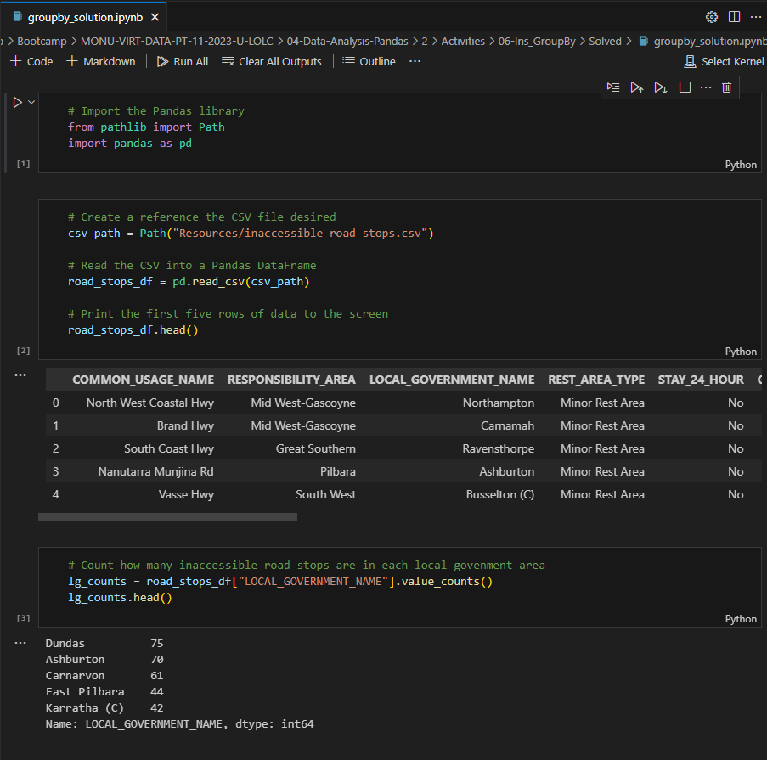

**Sorting multiple columns**

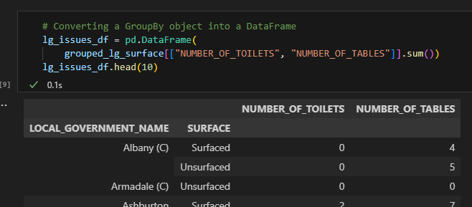

**Day 2, Activity 7 – Rented Properties (Group By)**

del state_totals_df['LGA']

**Day 2, Activity 8 – Sorting Data**

**Sorting by Multiple Columns by Highest to Lowest**

**Sorting by Multiple Columns by Highest to Lowest**

**Reset index number**

**Day 2, Activity 9 – Search for the Worst**

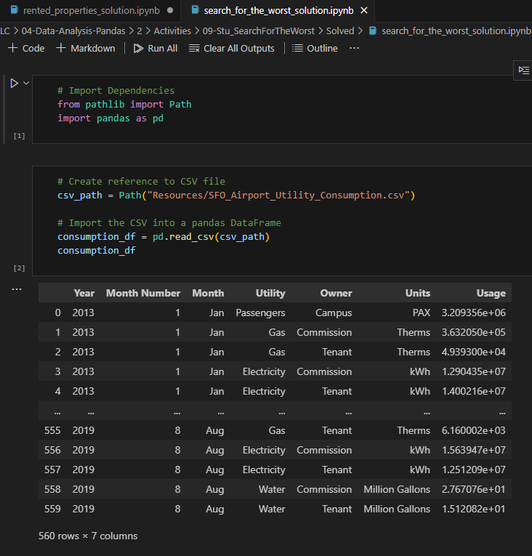

**Day 3, Activity 1 – Merging (using manual raw data)**

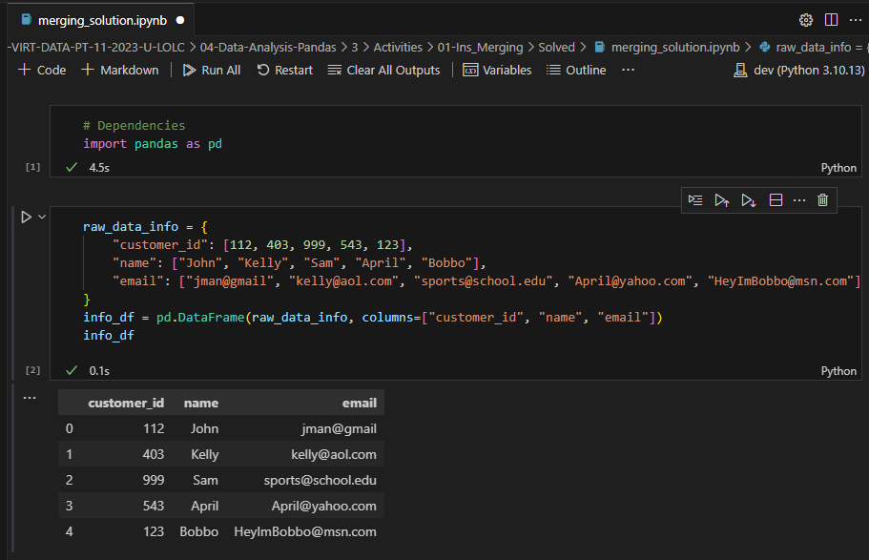

**Inner Merge and Outer Merge**

**Left and Right Merge**

**Day 3, Activity 2 – Merging (using 2 CSV files) – Government Spending**

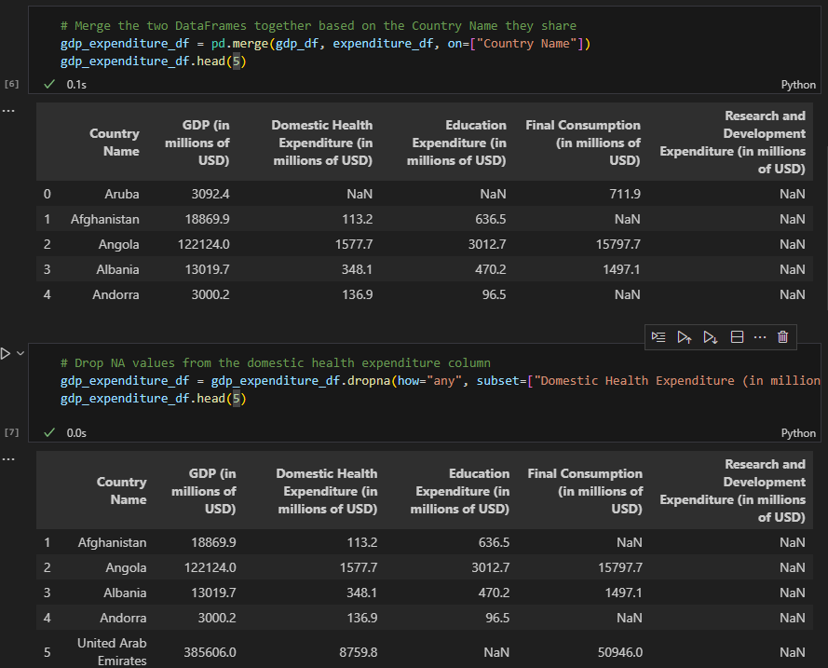

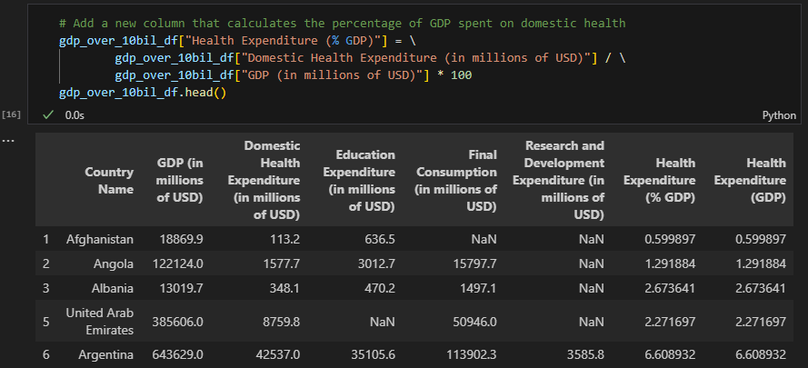

**Highest to Lowest**

**Reset Index**

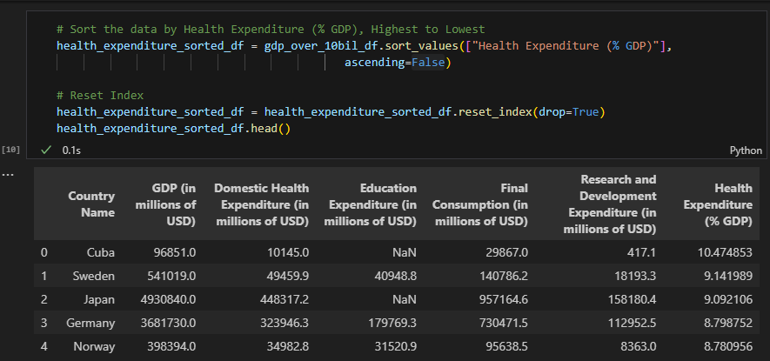

**The 0 is from the top of the list (i.e the below example – Cuba)**

**The -1 is from the bottom of the list (i.e the below example – Cameroon)**

**Day 3, Activity 3 – Binning (manual data)**

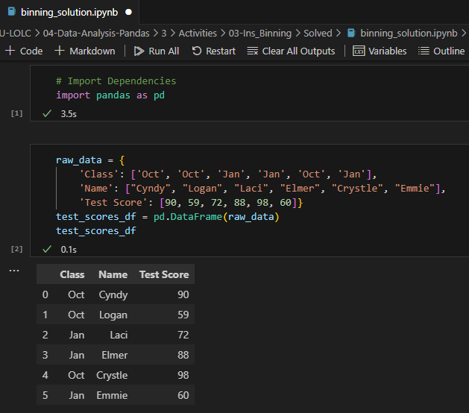

**Day 3, Activity 4 – Movie Ratings – Binning (via csv file)**

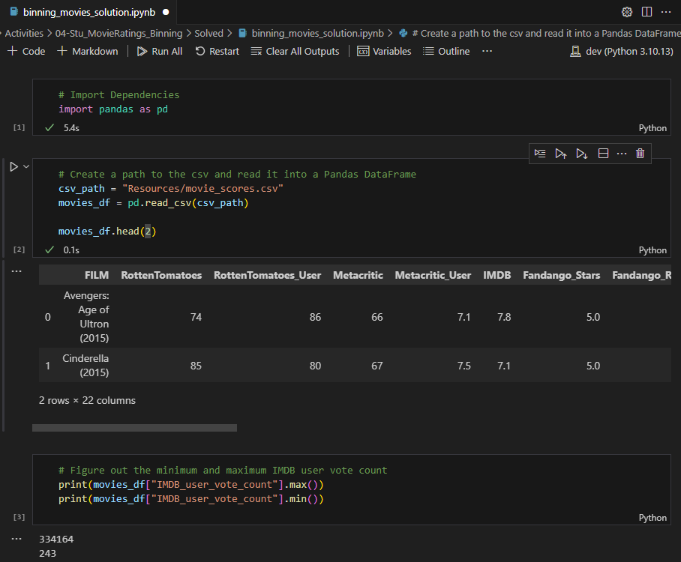

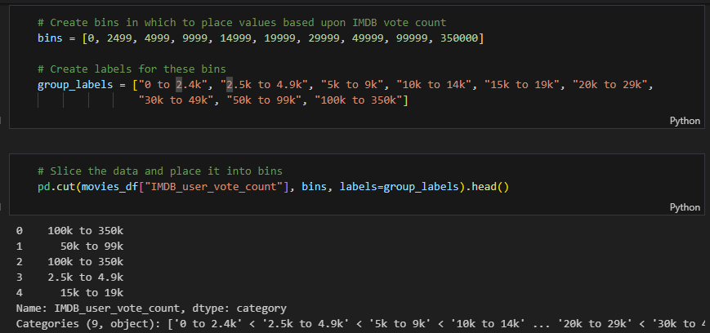

**Binning Data 🡪 pd.cut**

**Group by**

**Day 3, Activity 5 – Mapping / Formatting (via csv file)**

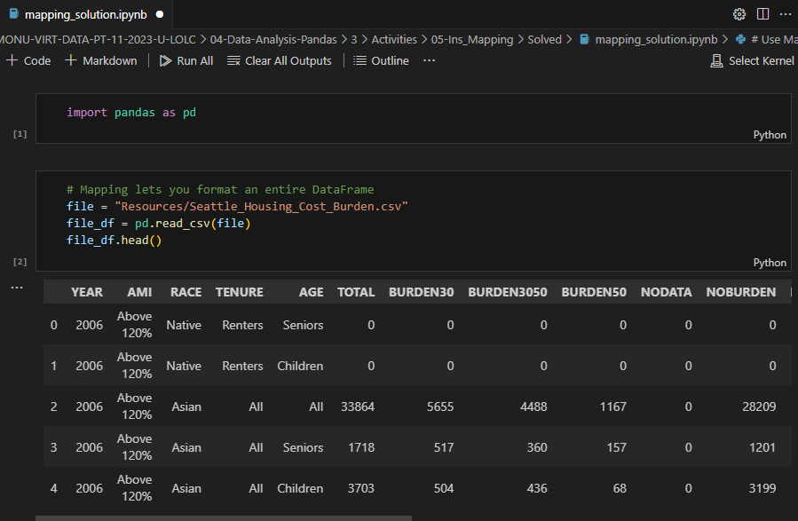

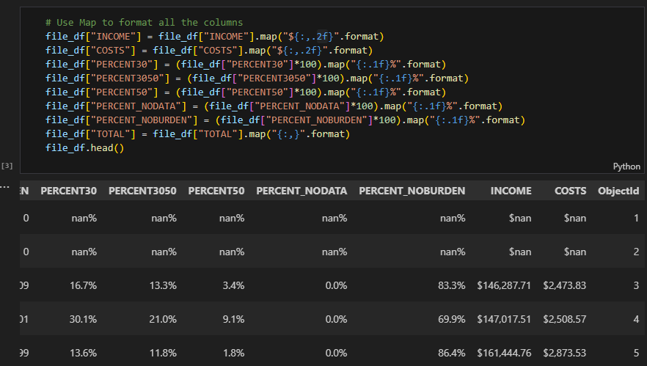

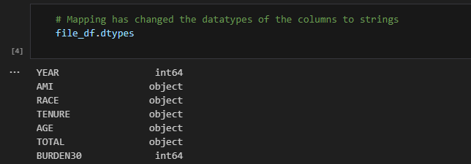

**Day 3, Activity 6 – Evr Crowdfunding**

